Minerva

Senior Design Team Contract 2019-2020

# Project Name: Minerva

Problem Statement: “According to statistics compiled by Click Boarding, an onboarding software company in Eden Prairie, Minn., the value of a structured onboarding process or program is that 69 percent of employees are more likely to stay with a company for three years if they experienced great onboarding.” (Hirsch, 2017). One of the largest problems facing a new \employee or intern is getting acclimated to the new work environment. After finishing the stressful procedure of getting hired onto a new job. New hires then must deal with the strenuous task of trying to fit in at your new job. The research we have completed shows that without a structured onboarding program employees were over 50% more likely to stay with a company for more than three years. We will develop a centralized onboarding application that will lead to a decrease in new hire turnover within the first three years.

Solution: Our solution is to create a web-based application that will be able to not only store any resources the new hires may need, but also give them access to resources that will allow them to get acclimated in a timely manner. We plan on assigning everyone their own personal drive or folder management system on a locally held server. We want to allow users to access this material from home before they come in for orientation. To do this we will use an in browser vpn that connects to their specific files and limits their access using active directory to hold their access.

## Contact Info:

|  |  |  |
| --- | --- | --- |
| Team Member: | Email: | Phone#: |
| Scott Sabelhaus (Project Manager) | [sabelhsp@mail.uc.edu](mailto:sabelhsp@mail.uc.edu) | (513)240-7063 |
| Joseph Johnston | [Johns7jh@mail.uc.edu](mailto:Johns7jh@mail.uc.edu) | (502)693-8815 |

Project Source: Minerva was introduced by Joseph Johnston as a tool to assist users who are new to a campus or college setting. Scott Sabelhaus and Joseph Johnston brainstormed and focused in on developing an application that will provide new hires in corporate workspaces a new innovative way to be onboarded. This will be a web-based app that will provide checklists for onboarding or incoming students to review online in a secure web-based environment. Users will be able to view things like their application, recruiter/advisor information, organization chart (corporate environments), and any educational material that needs to be reviewed prior to their first day.

Project Objective/Goals: Minerva is designed to combat the first day jitters of a new job and to guide the new hire to a more comfortable experience. Onboarding comes with a lot of stress for the new hires and for the trainers. Minerva will prevent misplacement of necessary documents and assign new hires the resources that will be most valuable to them in their assigned roles. In previous positions across several companies we have come across the issue of knowing next to nothing until the first few days on the job. This creates a tense and frustrating environment as new hires have to play catch up. In the event of change or miscommunication by either party, the new hire and company representatives will be able to view all the information and documents related to the orientation.

## Team Members/Responsibilities:

Scott Sabelhaus – Project Manager

* Developing the user interface and website design.
* Creating web based code and back end.
* Responsible for project plan and weekly updates.

Joseph Johnston

* Construction of Domain Controller (DC), Active Directory (AD), and web server using Windows server 2016/2019.
* Implementing firewalls and access control necessary for information security
* Developing network server and active directory system.
* Automation of account creation

Scope of project: Minerva will be built in a web app environment that will be mobile friendly. The application will be built using HTML, ASP.NET, Microsoft SQL Server, pfSense Firewalls, Windows Server 2019, and Pulse VPN.

Project Timeline/Gantt chart:

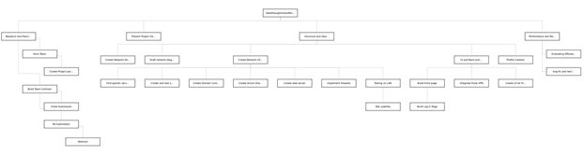

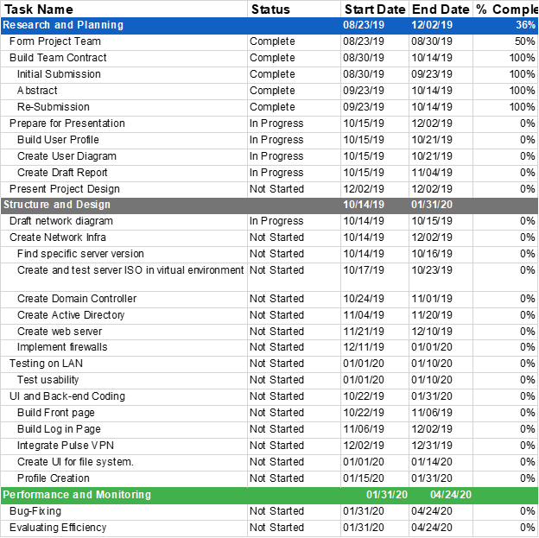

## 

## Team Rules/Escalating to Faculty:

* No member shall plagiarize, it looks bad for the university, our professors and advisors, and most importantly ourselves.
* Any delay or missing material must be verbalized between the team members to ensure we are all on the same page.
* Any updates to online or public documents should have some kind of note attached or message sent to the other group members so that we are not trying to edit the same things.
* All members will need to have their information put together and online by midnight the night before an assignment is due so that we have 24 hours to read over any information that has been added.
* If any of these rules are broken and we can not agree on a remedy then and only then will we get Yahya or a member of faculty involved.

## Team Signatures:

Scott Sabelhaus Joseph Johnston

Signature Scott Patrick Sabelhaus Signature Joseph Hunter Johnsotn

Date 9/23/19 Date 9/23/19